Welcome to the Summer House in Ingarö

Your Guide to a Relaxing Stay in the Stockholm Archipelago

Welcome to the Summer House in Ingarö 1
Your Guide to a Relaxing Stay in the Stockholm Archipelago 1
🚗🚌 How to Get to the Summer House 2
🔑 Access to the House 2
📺🎵 Internet, TV & Music Setup 3
💡🔌 Garden Electricity Control 4
♻️🗑️ Recycling & Waste Management 4
🍖🔥 Using the BBQ Grill 6
🧺 Laundry Instructions 7
⚡ Power Outage Instructions 8
🏄‍♂️ Stand-Up Paddle Boards (SUP) 9
🚲 Using the Bicycles 9
🔥🏠 Using the Fireplace (Chimney) 10
🗺️🌊 Exploring the Surroundings of Långvik-Ingarö, Värmdö 11

🚗🚌 How to Get to the Summer House

The summer house is located at Lagerbäcksvägen 11, in the beautiful Stockholm archipelago.
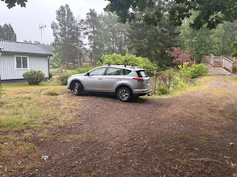
By Car:
You can drive from central Stockholm, which takes approximately 35 minutes. You can park directly in front of the house.

By Public Transport:
Take bus 429X from central Stockholm (Slussen). The bus stops at Fåruddsvägen.

From the Fåruddvägen bus stop, it’s just a 5-minute walk to the house.

🔑 Access to the House
When you enter the garden, you will see a key box with a pin code. Please enter the code and take out the key. Use it to open the main door.
Inside, you will find another key box in the kitchen. Open it to access a full set of keys. These keys will give you access to:
- The guest house
- The basement
- the storage rooms
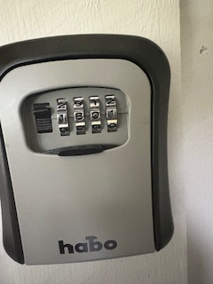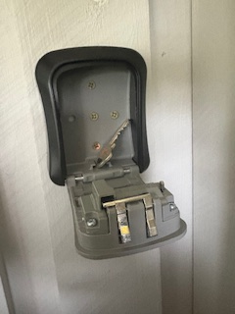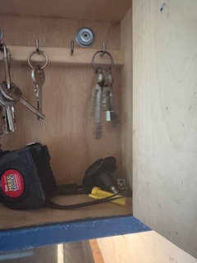
access to Internet and TV

📺🎵 Internet, TV & Music Setup
On top of the refrigerator, there is a cabinet where you’ll find:
- The Internet router (brand: D-Link)
- The TV and multimedia receiver (NVIDIA Shield TV)
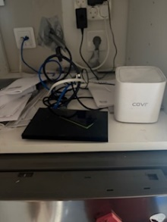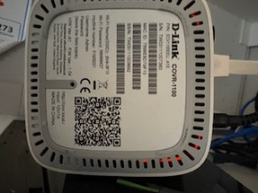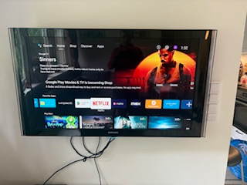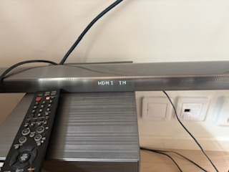
Internet Access
The Wi-Fi credential code is shown in the picture provided. interface.

TV Setup
- The Shield TV is connected to the living room TV via HDMI 3.
- When turning on the TV, make sure to select HDMI 3 as the input source.
- You can pull out the TV to see all the connected cables if needed.
Sound System
- For better sound, the TV is connected to a sound receiver (or soundbar) and subwoofer.
- The connection from the TV to the soundbar is via HDMI 1.
- On the soundbar, make sure to select the HDMI source (see picture for reference).
Remote Controls
You have two remote controls:
- Shield TV Remote – for navigating the multimedia system (found in the cabinet above the fridge).
- Samsung TV Remote – mainly used to turn the TV on and off.
You can also manually turn on the TV by touching the blue LED under the screen

💡🔌 Garden Electricity Control
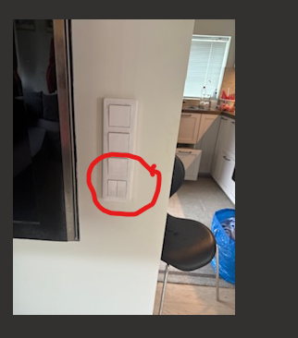
The electricity in the garden is managed by three switch buttons located near the TV inside the house:

Switch 1 – Turns on the light near the well, close to the house.
Switch 2 – Turns on the garden lighting.
Switch 3 – Powers the electrical outlets in the garden (for plugging in devices like lights, tools, or chargers).

♻️🗑️ Recycling & Waste Management
This section explains how to handle garbage and recycling during your stay.
1. General Waste (including food waste)
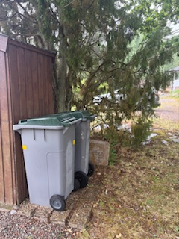
- When you enter the garden, you’ll see two large garbage bins.
- Use the bin closest to the tree – this one belongs to the house.
- The other bin is for the neighbor – please do not use it.
2. Paper & Plastic
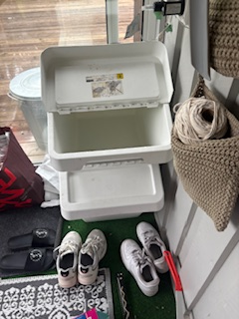
- Inside the glass house (where you found the key instructions), you’ll find two white plastic bins:
  - One is for paper.
  - The other is for plastic.
3. Glass & Metal
- Outside the glass house, you’ll see two aluminum bins:
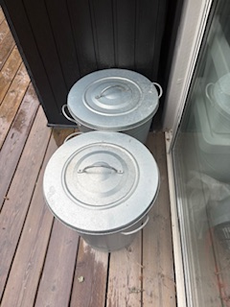
  - One is for metal cans and bottles.
  - The other is for glass bottles.

🍖🔥 Using the BBQ Grill
Near the entrance of the building, you’ll find a BBQ grill with a protective cover.
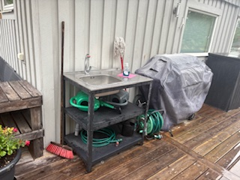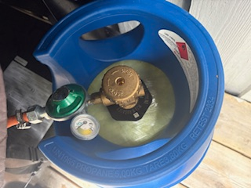
Steps to Use the BBQ:
- Remove the cover to access the grill.
- You’ll see a gas bottle connected to the BBQ.
- Open the gas valve by turning the knob in the direction marked “Open” (check the arrow on the bottle).
- Once the gas is on, use the ignition switch on the BBQ to light it.
- The BBQ has five control knobs – use them to adjust the heat as needed for even cooking.
🔥 Safety Tip: Always make sure the gas is turned off after use, and never leave the BBQ unattended while it’s on.

🧺 Laundry Instructions

The washing machine is located in the basement. It is a combined washer and dryer, so you can both wash and dry your clothes in the same machine.
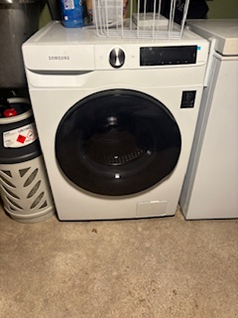
How to Use:
Choose the appropriate program on the machine.
Add laundry detergent in the detergent compartment.
If there is no detergent available, you are welcome to purchase your own.
🧺 Tip: Make sure not to overload the machine for best results.

⚡ Power Outage Instructions
In case of a power outage, you’ll find the main power switch box in the basement.
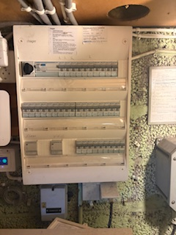
- It is an automatic fuse box.
- When the power goes out, some switches may flip to the OFF position.
- Simply push the affected switches back up to restore power.
⚡ Note: Only touch the switches if you feel comfortable doing so. If the issue persists, please contact the host.

🏄‍♂️ Stand-Up Paddle Boards (SUP)
The stand-up paddle boards (2 boards) are stored in the basement.
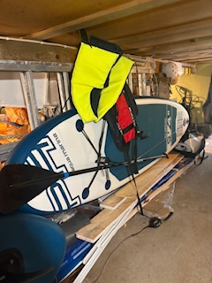
How to Use:
- Inflate the boards using the bicycle pump provided. Make sure to pump until the board reaches the recommended pressure (usually marked on the board).
- Life jackets are also available in the same storage area – please wear one for safety.
- You can carry the boards to the nearest launch spot, which is about 500 meters from the house.
🌊 Tip: Always check the weather and water conditions before heading out, and never paddle alone if you're unfamiliar with the area.

🚲 Using the Bicycles

There are four bicycles available in different sizes, suitable for both adults and older children.
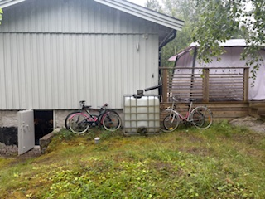
The bikes are located in the garden, near the basement door (see picture for reference).
Feel free to use them during your stay – just make sure to return them to the same spot after use.
🚲 Tip: Check tire pressure and brakes before riding. Helmets are recommended for safety.

🔥🏠 Using the Fireplace (Chimney)

The fireplace is located in the living room and can be used for warmth and a cozy atmosphere.
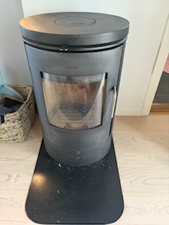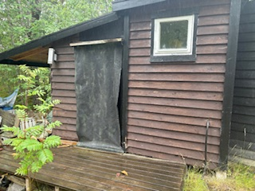
How to Use:
Firewood is available in the wood storage located in the garden.
Before lighting the fire, make sure the airflow is open to allow proper ventilation.
You can adjust the air intake by turning the control left or right (check the pattern or markings on the handle).
Light the fire carefully and never leave it unattended.
🔥 Safety Tip: Always ensure the chimney is drawing air properly before lighting the fire, and keep the Relaxing in the Garden

Take a moment to unwind and enjoy the peaceful atmosphere of the garden. There are several ways to relax and have fun:
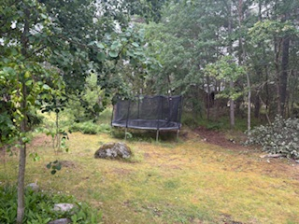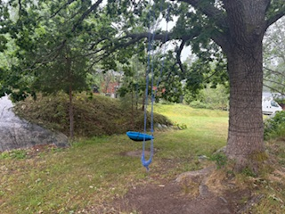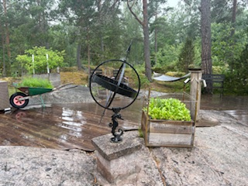
A comfortable hammock for resting or reading.
A swing that children (and playful adults!) can enjoy.
A jumping mat (trampoline) for some light exercise or fun bouncing.
Feel free to enjoy the space at your own pace — whether you're looking to relax or play. glass door closed while burning.

🗺️🌊 Exploring the Surroundings of Långvik-Ingarö, Värmdö

The area around the summer house offers plenty of opportunities for relaxation, nature experiences, and fun activities for the whole family.

🌊 Water Activities
You can go swimming in nearby lakes and the sea.
Try stand-up paddleboarding in Långvik’s bay.
There are several spots for water sports and peaceful places to relax by the water.
🍽️ Dining & Beaches
If you drive about 2–3 kilometers from the house, you’ll reach Björkvik (Bear Peak).
There you’ll find Björkvik’s Bistro, a cozy restaurant with great food and drinks.
The area also several beaches in the area:
Stora sandarna, Lilla sandana, Björkvistrand
🌲 Nature & Adventure
The region includes the Björkvik National Park, perfect for hiking and biking.
You can rent kayaks and explore the coastline or lakes.
Cycling is a great way to discover the area’s natural beauty and hidden gems.

